**Creating a new Virtual Network with a new affinity group**

The first task is to create a new Virtual Network to your subscription with a new affinity group.

1. Open a browser and go to <https://manage.windowsazure.com/>. When prompted, login with your **Microsoft Azure**credentials. In the Microsoft Azure Portal, click **New**, select **Networks** | **Virtual Network** and then click **Custom Create**.

[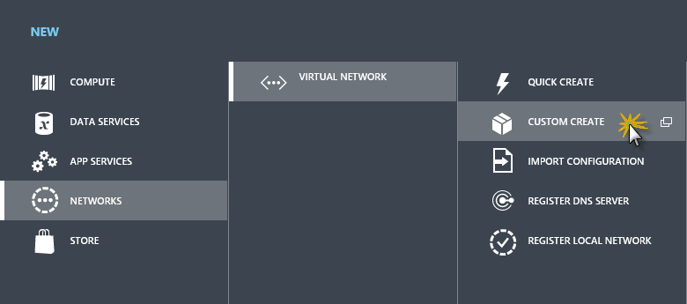](https://github.com/Azure-Readiness/MicrosoftAzureTrainingKit/blob/master/HOLs/HOL-ConnectingApplicationsVNet/Images/virtual-network-custom-create.png?raw=true)

*Virtual Network custom create*

1. Set a Name for the virtual network, for example *MyVNET*. Select Location and click the arrow button to continue.

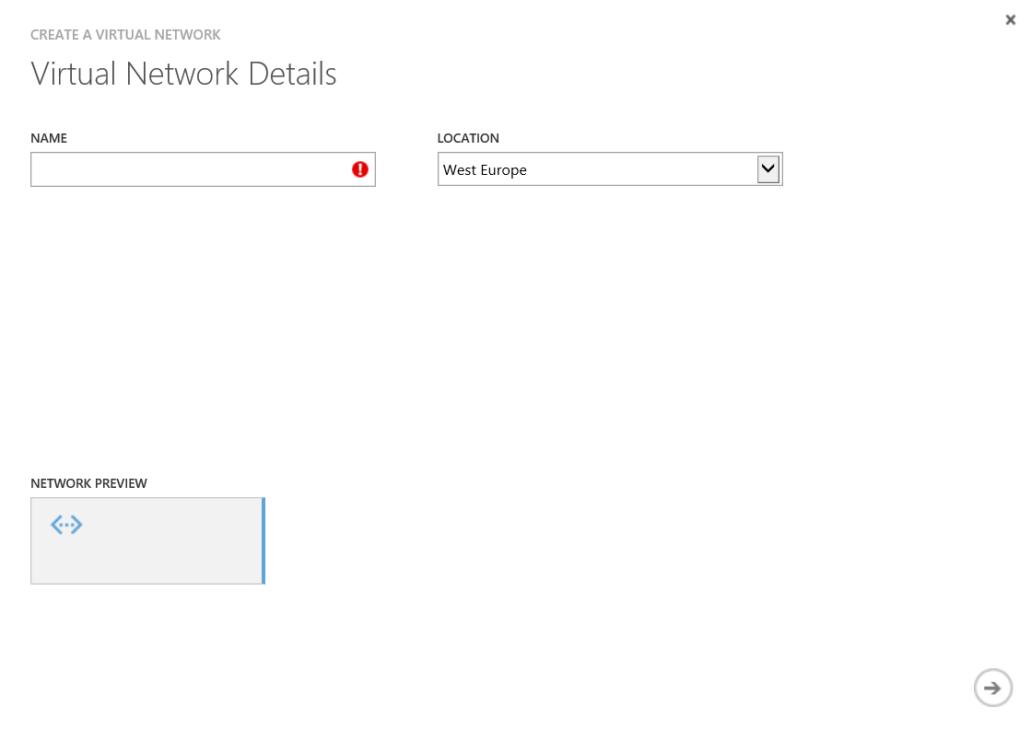

*Creating a new virtual network*

1. Leave default settings for DNS and click the finish button.

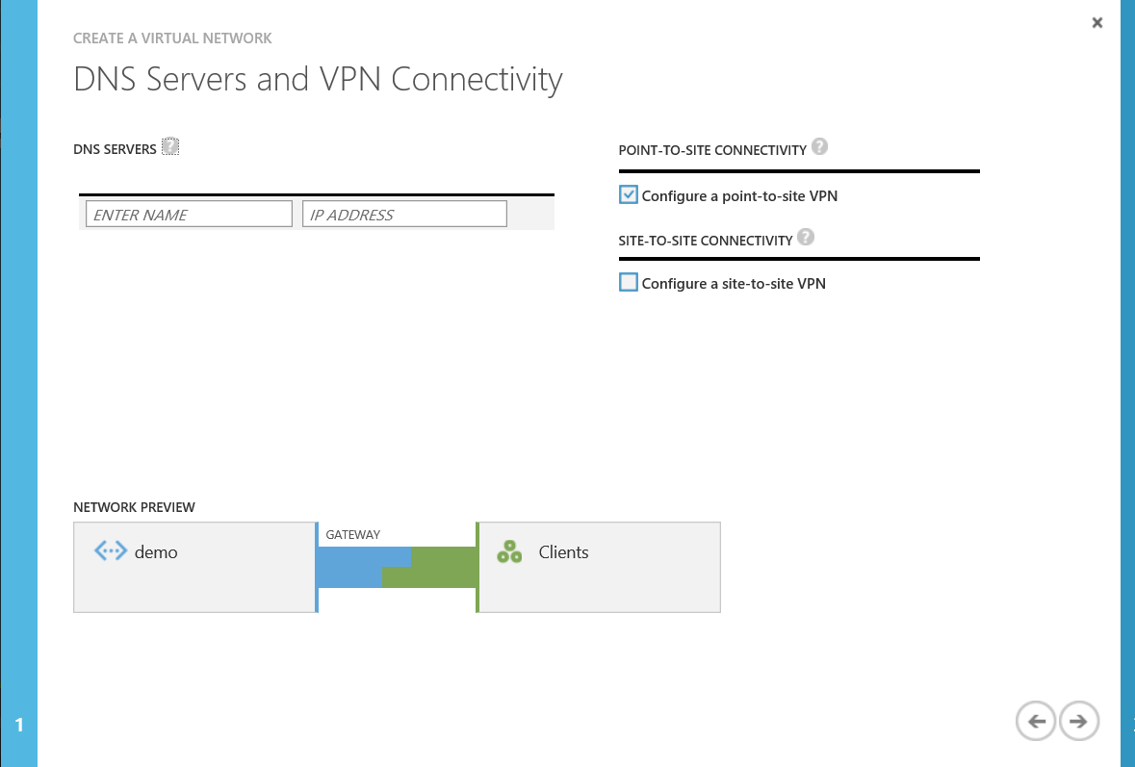

1. Set the Address Space Starting IP value to *192.168.0.0* and its Address CIDR to */24*. Finally,  
   Click the arrow button to continue to the next step.

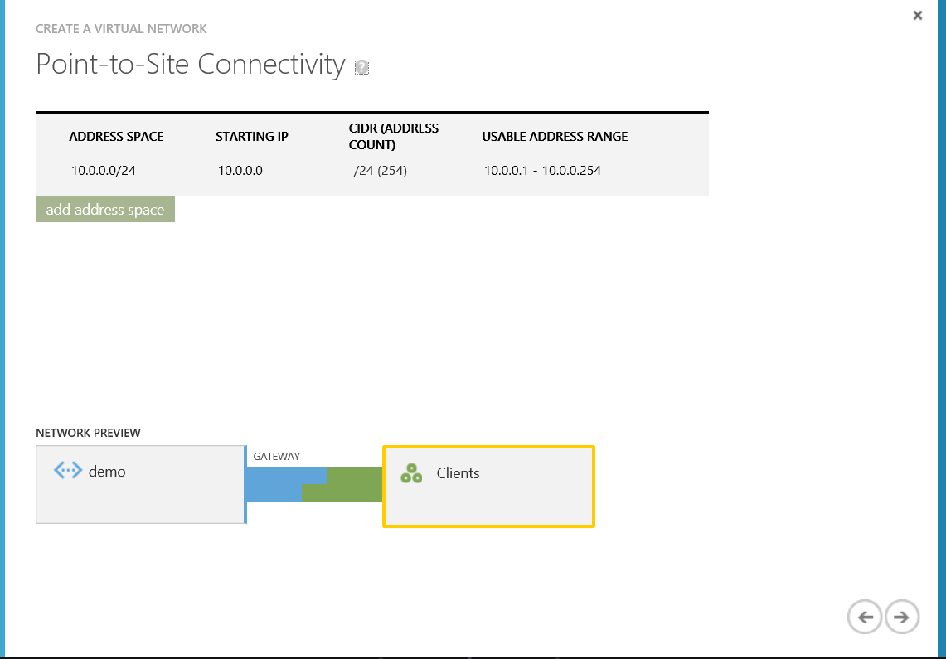

*Adding an address space and subnets*

1. Click the Add a Gateway Subnet button and leave it on the default settings

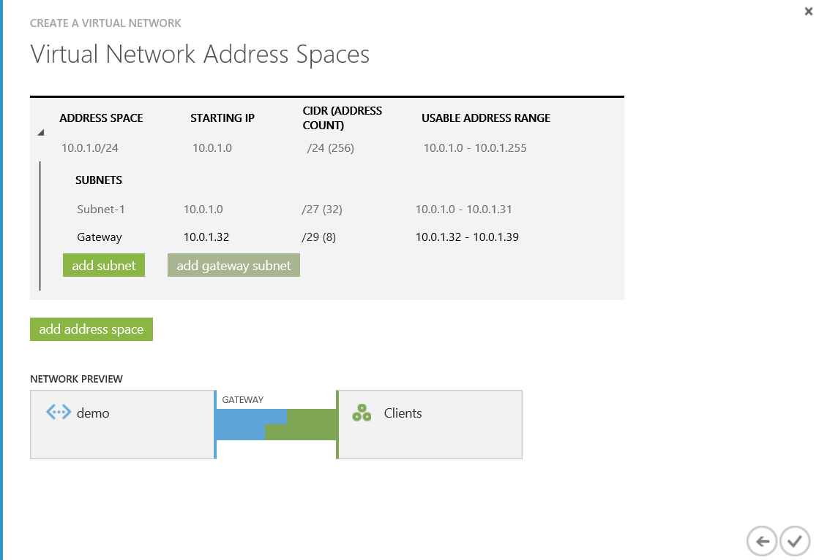

1. On the Networks page, click the virtual network that you just created, and navigate to the Dashboard page.

Click Create Gateway, located at the bottom of the Dashboard page.   
A message will appear asking, Do you want to create a gateway for virtual network ‘yournetwork’. Click Yes to begin creating the gateway. It can take around 15 minutes for the gateway to create.

1. Create your certificates
   * To create certificates we are going to use .Net SDK

If you have visual studio or windows SDK on your machine you might already have it

If not go ahead download and install it from

Windows 7 : <http://www.microsoft.com/en-us/download/confirmation.aspx?id=8279>

Windows 8.1 : <http://www.microsoft.com/click/services/Redirect2.ashx?CR_EAC=300135395>

1. Open CMD and Navigate to folder   
   C:\Program Files (x86)\Microsoft SDKs\Windows\v7.1A\Bin\x64
   * Run this command to create and install your ROOT Certificate

makecert -sky exchange -r -n "CN=<CertName>" -pe -a sha1 -len 2048 -ss My "<Folder>\<FileName>.cer"

* + Run this command to generate and install the Client Certificate   
    Make sure you user the same CN name from the ROOT certificate

makecert.exe -n "CN=<The ROOT Cert name>" -pe –sky exchange -m 96 -ss My -in "RootCertDemo" -is my -a sha1

Keep in mind that this ClientCertificate will be used for any client machine that will connect to the Network

1. In the same foler in the CMD run
   * Certmgr

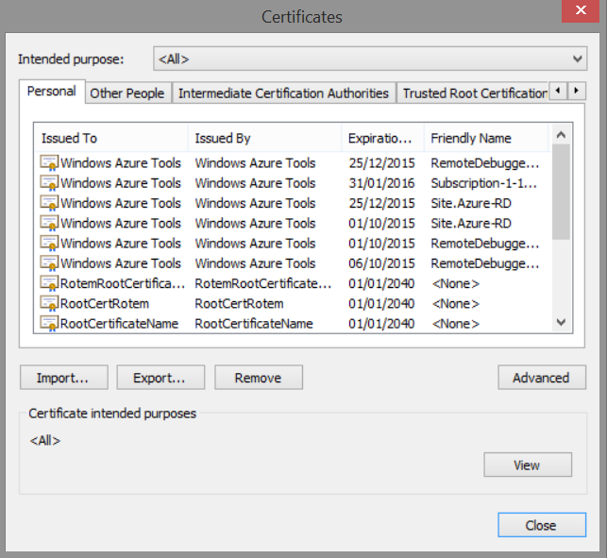

1. Find the Client Certificate you just generated

Select it and click the Export button

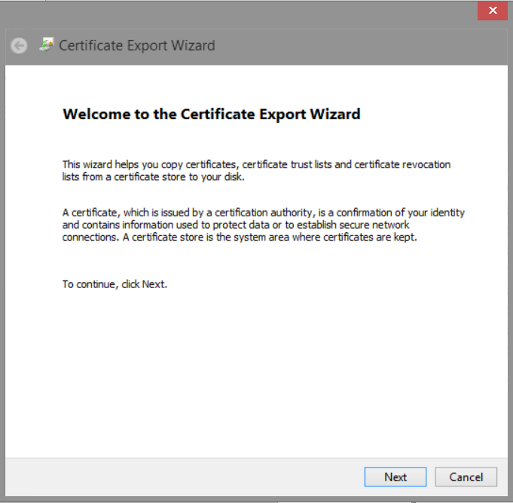

Click Next

Select Yes, export the private key

Click Next

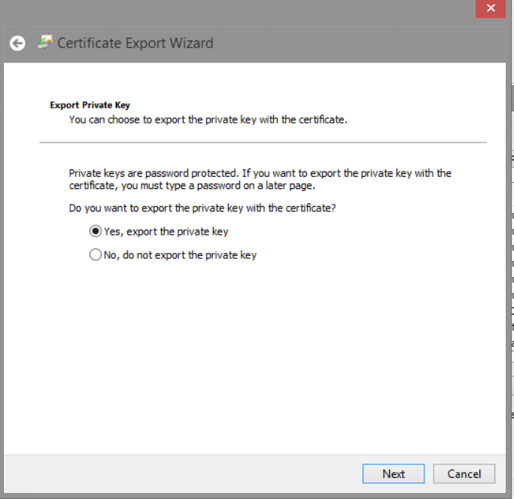

Leave it on the default settings  
Click Next

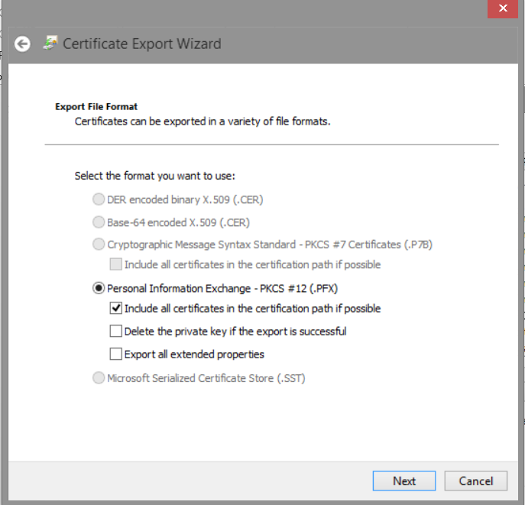

Click on the Password Checkbox

Set the password (make sure to remember it) it will be used to install the client certificate on other machines

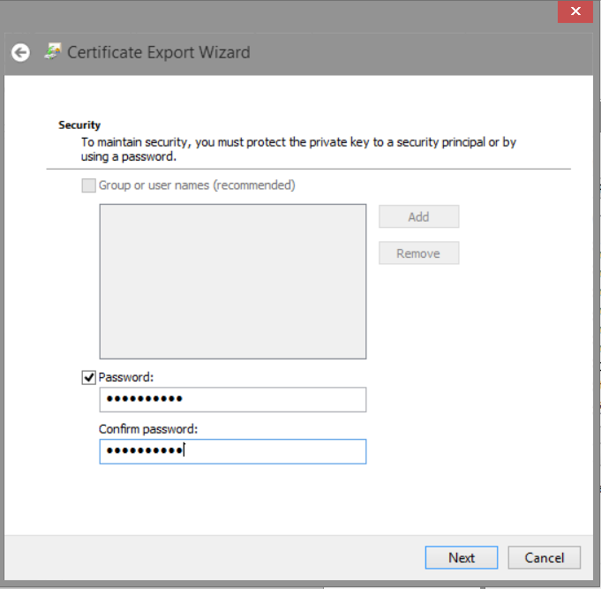

Browse to the location you want to save the file at   
I recommend at this point to save the root certificate and the client certificate on the same folder   
Click Next

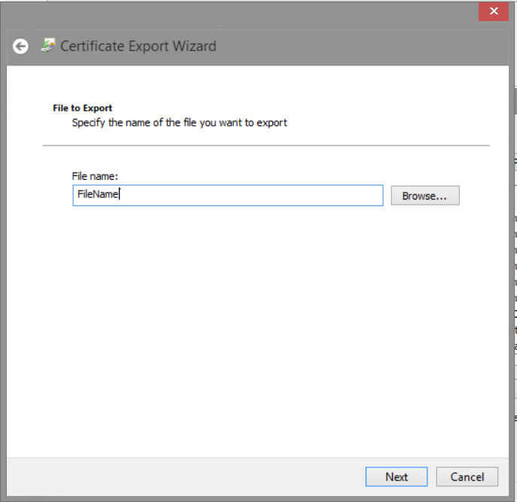

1. Upload the root certificate to the portal
   * In the Management Portal, on the Certificates page for your virtual network, click Upload a root certificate.
   * On the Upload Certificate page, browse for the .cer root certificate and upload it.
2. When the Root certificate is installed go to the dashboard
   * YOU CAN SEE NOW 2 NEW LINKS TO DOWNLOAD vpn installers

32bit and 64bit

* + Select the download package that corresponds to the client operating system on which it will be installed and install it

1. The next step is to create a virtual machine and place it in this newly created virtual network. To do this, click **Virtual Machines** in the navigation pane and click **Create a Virtual Machine**.

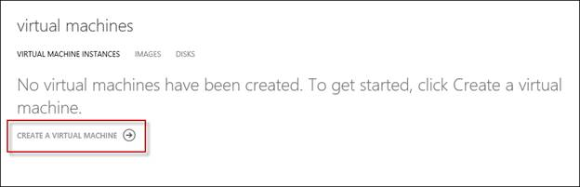

1. Choose **From Gallery** and then select an image to use.

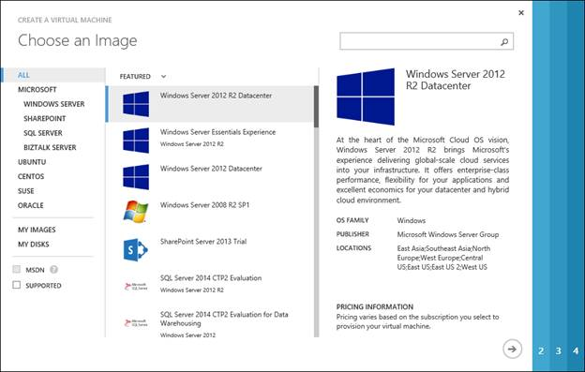

1. Give the virtual machine a name, select the size of the VM, and specify a new username and password.

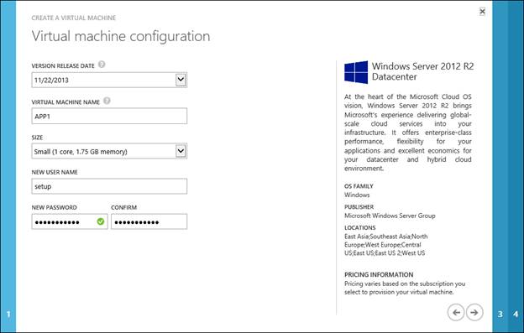

1. Provide a unique DNS name for the cloud service, select the affinity group you created earlier, and then select the virtual network subnet you wish to place the virtual machine in.

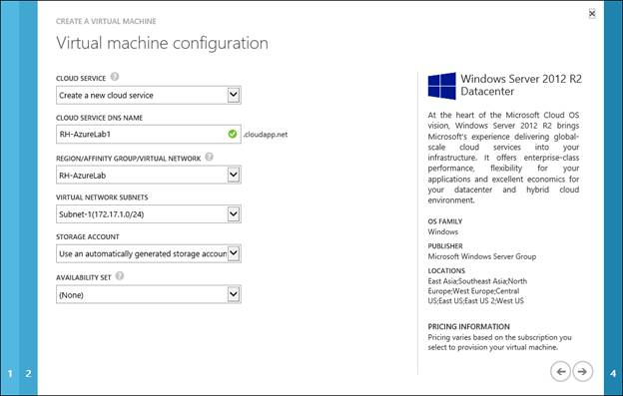

1. Leave the port configuration on default

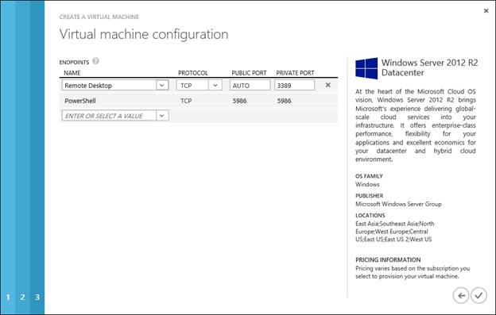

1. Once the virtual machine has been created and provisioned, go to the dashboard for the VM and you’ll observe that the new VM has a private internal IPv4 address from your newly created virtual network. Note also that the VM has a public virtual IP address as well.

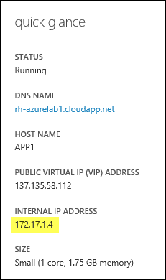

1. When the machine is up and running you can go to the endpoint tab and remove the RDP endpoint
2. No we cannot RDP to the machine threw the public IP
3. No go ahead and connect to the VPN we created and connect to the machine VIA the private port

If everything was done you should be able to connect to the machine